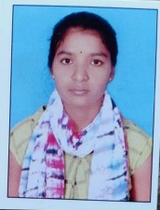RESUME

NAME
Chandana kandela
Phone : 6301770828
E-mail : kandelachandana@gmail.com

CAREER OBJECTIVE
To obtain a challenging position as a Software Engineer in a leading multi-national organization where I can use my qualifications and skills to prove my abilities.

EDUCATIONAL QUALIFICATIONS
S.  No. | Examination Passed | Name  of Institute/ University | Discipline/ Subject | Month & Year of  Passing | Percentage of  Marks | Division
1. | B. Tech | Ace Engineering College  Ghatkesar. | Artificial intelligence and machine learning | 2025 | 8.0 | First
2. | Intermediate | Sr junior college Nizamabad | Maths, Physics, Chemistry. | March 2019-  21 | 82 | First
3. | S.S.C | Telangana State Model School | Maths, Science,  Social Studies | March 2019 | 97 | First
TECHNICAL PROFILE
Languages : C , PYTHON.

ACHIEVEMENTS
NPTEL Certificate: The Joy Of Computing Using Python ACE CODE PRAGNA: Round 1 and round 2 Cisco:Essentials in c
Cisco:Essentials in python

STRENGTHS
Positive Attitude
Patience.

WEAKNESSES
Have a difficulty in saying NO

HOBBIES
Reading Books
Travelling
Dancing

PERSONAL PROFILE
Date of Birth : 21st may 2003 Languages known : English, Telugu. Father's Name : Mr. Gangadhar
Mother’s Name : Mrs. Sujatha

Address : H-no.3-18/2 Badguna,Nandipet Nizamabad 503212

DECLARATION :

It is hereby acknowledged that the information furnished above is true to my knowledge.
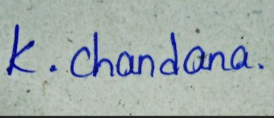

Place : Hyderabad Signature

Date : 11/11/2022

* * *

